

Upcoming Dates:
Half Days:
IMAGE classes will not meet on any half days.

Fifth Grade Reminder:
GVSU engineering field trips are on
Nov. 14th (Maroon class) & 15th (Bulldog class).
Please send in your student’s permission slip, if you have not already.

Conference Dates (see the attached form):
Monday, December 5th
Wednesday, December 7th
Friday, December 9th
Monday, December 12th
Wednesday, December 14th

4th Grade Claymation Premiere:
January 26th at 7pm in the middle school auditorium

IMAGE Staff
Ashley Dickinson: 254-6803
Program Teacher/ Coordinator
adickinson@gpsbulldogs.org
Ryan Roberts: 254-6212
Principal at South
rroberts@gpsbulldogs.org
Classroom Website: imagebulldogs.weebly.com

Report Cards
IMAGE students will no longer receive traditional IMAGE report cards. This change was necessitated by two factors. First, this year we have over 150 students in the program, which makes elementary report cards extremely time consuming. Second, since our clerical aid position was eliminated, there just isn’t enough assistance to print, label, and mail these documents in a timely manner.

However, your student will still receive a grade at the conclusion of each IMAGE project. This will come on a detailed rubric. This rubric will hopefully help breakdown their grade so that you can see what areas your student is excelling in and what areas we are working on. In addition, the bottom of the rubric will also contain behavior information. If you ever have any questions about your student’s grade, please don’t hesitate to contact me. For most students, their first graded rubric will come home after the holiday break during early January.
Also, please keep in mind that IMAGE projects are meant to challenge your student. Therefore, the bar is set higher for these projects than it might be in a regular classroom. Please use these project grades to celebrate your student’s effort and also to discuss with them ways they can grow in the future, rather than expecting a perfect score.

Parent Book Club
I’d like to invite you to participate in our parent book study beginning later this month. We will read Supporting the Emotional Needs of the Gifted, which contains essays compiled by S.E.N.G. You can view their website at http://sengifted.org/ For the book study, you can request one of the copies from our IMAGE classroom library, or the book is also available on Amazon.com. Our meetings will be on Mondays from 1-2pm in the IMAGE classroom at South Elementary. We plan to discuss the book and enjoy some coffee two afternoons each month. If you’d like to participate, please click on this link to register, or fill out the form included with this newsletter instead.
Online Registration
Meeting Dates:
Monday, November 14th
Monday, November 28th
Monday, December 12th
Monday, December 19th
Monday, January 9th
Monday, January 23rd

Classroom News:
3rd Grade Gerfuls/Bloom’s Taxonomy
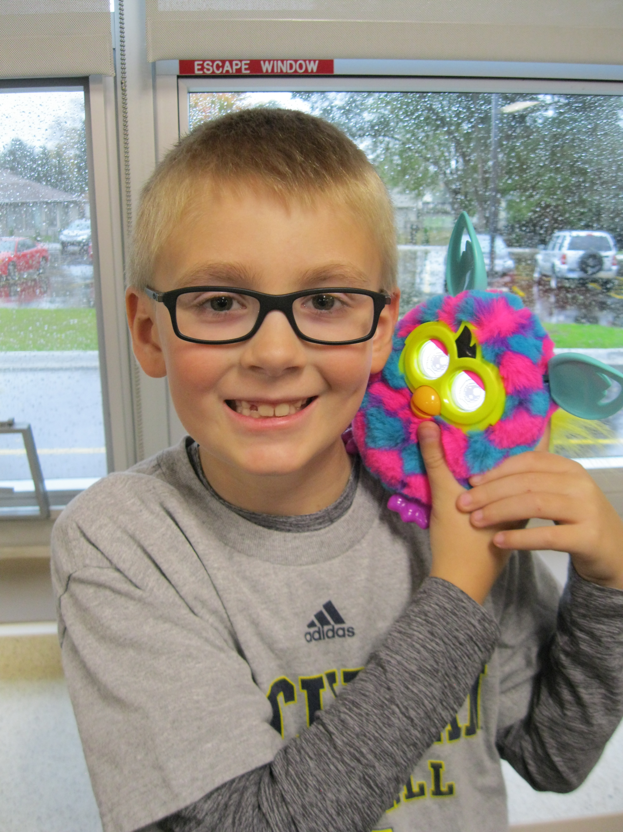
The students are now finishing up our study of Bloom’s Taxonomy of thinking levels. By the end of this unit, students will have learned a lot about the levels of thinking and the mysterious species called the gerful. First, students began the unit by learning the basics about this imaginary creature (this was the remember level). Then, they proved that they understood those facts by choosing an activity to demonstrate their understanding (this was the second level). Some students illustrated a drawing of the gerful and wrote a topic sentence to go along with their drawing. Some students created a comic strip about the gerful and used narration and dialogue to explain what they knew. Other students wrote detailed paragraphs, which they then recorded themselves reading on our classroom computers. Next, we moved on to the apply level. During this step, they applied what they know about a gerful by designing a plan for their gerful habitat. Then, we went on to the analyze step. Students closely analyzed the gerful to dig deeper into the details. Some students created a three-way Venn diagram to compare and contrast the traits of a gerful with other animals. Some students created an outline that categorized the facts they had observed, and some other students created a detailed map of John Ball Zoo showing which section of the zoo the gerful best fit in, based on its physical traits. At this point, students were finally ready to move to the two highest thinking levels: evaluate and create. Students carefully evaluated the gerful by creating a report card for the creature. Then, students also looked back at all their IMAGE work so far to evaluate their own work, too. Throughout this process, students had fun learning about the imaginary gerful creature, but we also spent a lot of time discussing how to write topic sentences and support our thoughts with good details. Students were also able to reflect on their work by using a rubric, similar to the one I will use to grade their final project during this step, as well.
Students will finally get to work on constructing their gerful habitat this week!. If you have not sent in a small box or shoe box yet, please send one this week. To accompany their project, they will also type a paragraph explaining their habitat and how it is based on facts they learned about the gerful throughout this unit. Once the habitat and paragraph are finished, I will send home all their unit assignments, their final project, and a rubric with their grade. To see our class posing with our gerful friend, check out the “Student Work” link on our classroom website frequently. Here is a direct link to the site: 3rd Grade Student Work
Next, we will begin transitioning into our Medieval Times unit. Hopefully, from these first few months, your student is seeing that they will have lots of choices and challenges as they work through project-based units in IMAGE. If you have any questions or concerns about your child’s transition into IMAGE, please don’t hesitate to contact me prior to our conference time in December!
4th Grade / Claymation
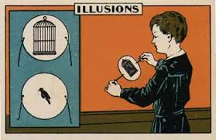
Students have been busy learning about different types of animation as they progress through the claymation unit. For example, they traced the early history of animation by making a Victorian era device called a thaumatrope, which relies on optical illusions to create an image. However, the students have also been hard at work researching, as well. They selected a partner to work with and chose an important American from history as the subject for their movie. Using online databases and books, they had to research their American, that person’s time period, and the region they lived in. This unit focuses a lot on language arts skills, but we are also incorporating social studies standards by learning about the regions of the U.S., too.
Students have just finished the research portion, and this research will now be used to create an illustrated timeline, a detailed drawing of their person, and a digital word mosaic. All these elements will be scanned into the computer to eventually become part of their final claymation movie. I will also begin to incorporate mini lessons on informational writing with the students, as we continue. This will support what they are doing in their regular classrooms and will prepare them to write the script for their movie. Later this month, students will be constructing their clay figures and background sets. I can’t wait to see the final projects and share them with you in January at our big premier night!
If you are interested to see our progress, please visit our classroom website and click on “Student Work” in the menu to the left. Soon, I’ll also update this website with photographs of the students’ clay figures, so you can follow along at home with their work. Here is a direct link:
4th Grade Student Work
5th Grade / Inventions
Fifth graders have been working hard learning about inventors, using creative thinking strategies, and completing our six invention stations. SCAMPER is our higher level thinking skill for this unit. SCAMPER teaches us how to look at an object or situation and modify it to solve a problem (substitute, combine, adapt, maximize/minimize, put to other uses, eliminate, and rearrange). They have been putting those skills to use every week, and I love seeing what they create during station time with the LEGOS and our Snap Circuit sets. We have a lot of future engineers in this class, I think!
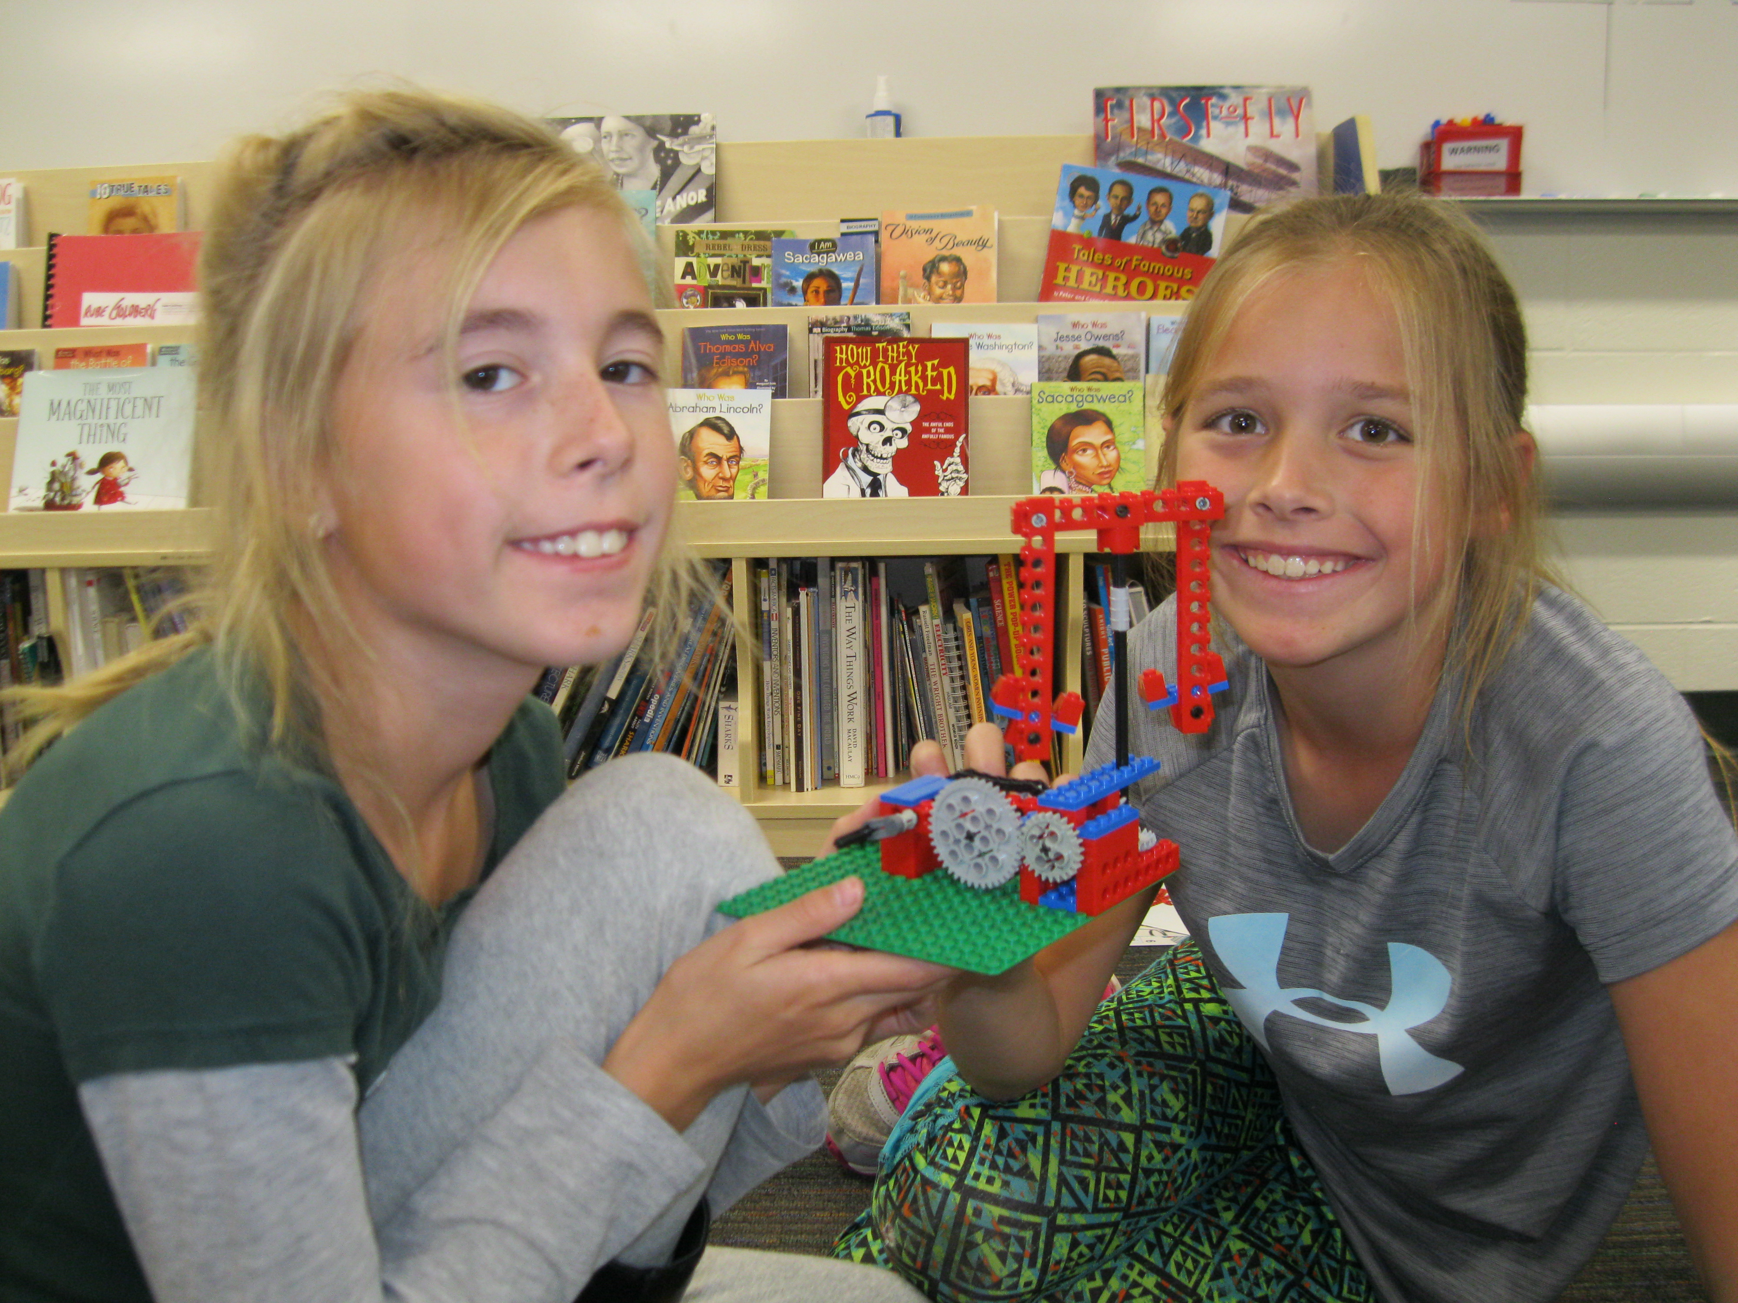
It has been fun recreating some famous inventions from the past, too! In past weeks, we created water clocks, a Native American travois, and also made our own primitive paper from dryer lint (not exactly how the ancient Chinese inventors did it).
However, our unit will soon change focus as we culminate our learning with an inventor research project. Each student will select an inventor of their choice to research. At home, you can begin to discuss what inventions have made a big impact on society with them to help your student begin to decide on an inventor for their project. They will eventually use their research as a basis for creating their own trading card and a comic book that will teach the class about their inventor’s life. This should put a fun spin on our research.
For now, please enjoy these images and videos of our students hard at work at their inventor stations. You can always visit our classroom website and click on “Student Work” in the menu to the left. However, here is the direct link: 5th Grade Student Work

5th Grade GVSU Field Trip
We will be traveling to GVSU’s downtown engineering campus to tour the robotics lab and engineering facility soon. Your student’s field trip will be on November 14th or 15th. The facilitator at GVSU has asked that your child come wearing closed toed shoes and long pants the day of their field trip because we may have an opportunity to walk through the lab. Please be sure that you have turned in your student’s permission slip. I will be contacting parent chaperones with more information later this week!

6th Grade/ Public Art
Many of my sixth graders have been stepping outside of their comfort zones and doing a fantastic job on their art portfolio pieces. A few terrifying paper mache gargoyles are finished, many abstract pieces of duct tape art now cover my shelves, and subtractive sculptures made from bars of soap have left a distinctive scent lingering in my classroom! In addition, quite a few students designed a keychain or set of dice online and were able to print it on our 3D printer. Hopefully, they learned a lot about art history and vocabulary as they explored new styles and materials during our art workshop time. The exploratory part of our unit will culminate with a classroom art prize competition in class I n a few weeks. Look for their artwork on our classroom website soon.
At our Frederik Meijer Gardens field trip, our students were able to see many examples of sculpture, which I hope will inspire them as we get ready to begin our final art & design project for this unit. On this field trip, each student also participated in a hands-on activity where they constructed a sculpture as a group using reclaimed metal, screws, nuts, and bolts. Thanks again to all the parents that attended with us!

Since students have the basic elements of art vocabulary down now, we’ll be shifting our attention away from famous two-dimensional paintings and begin to focus more on three-dimensional sculptures and our final project.
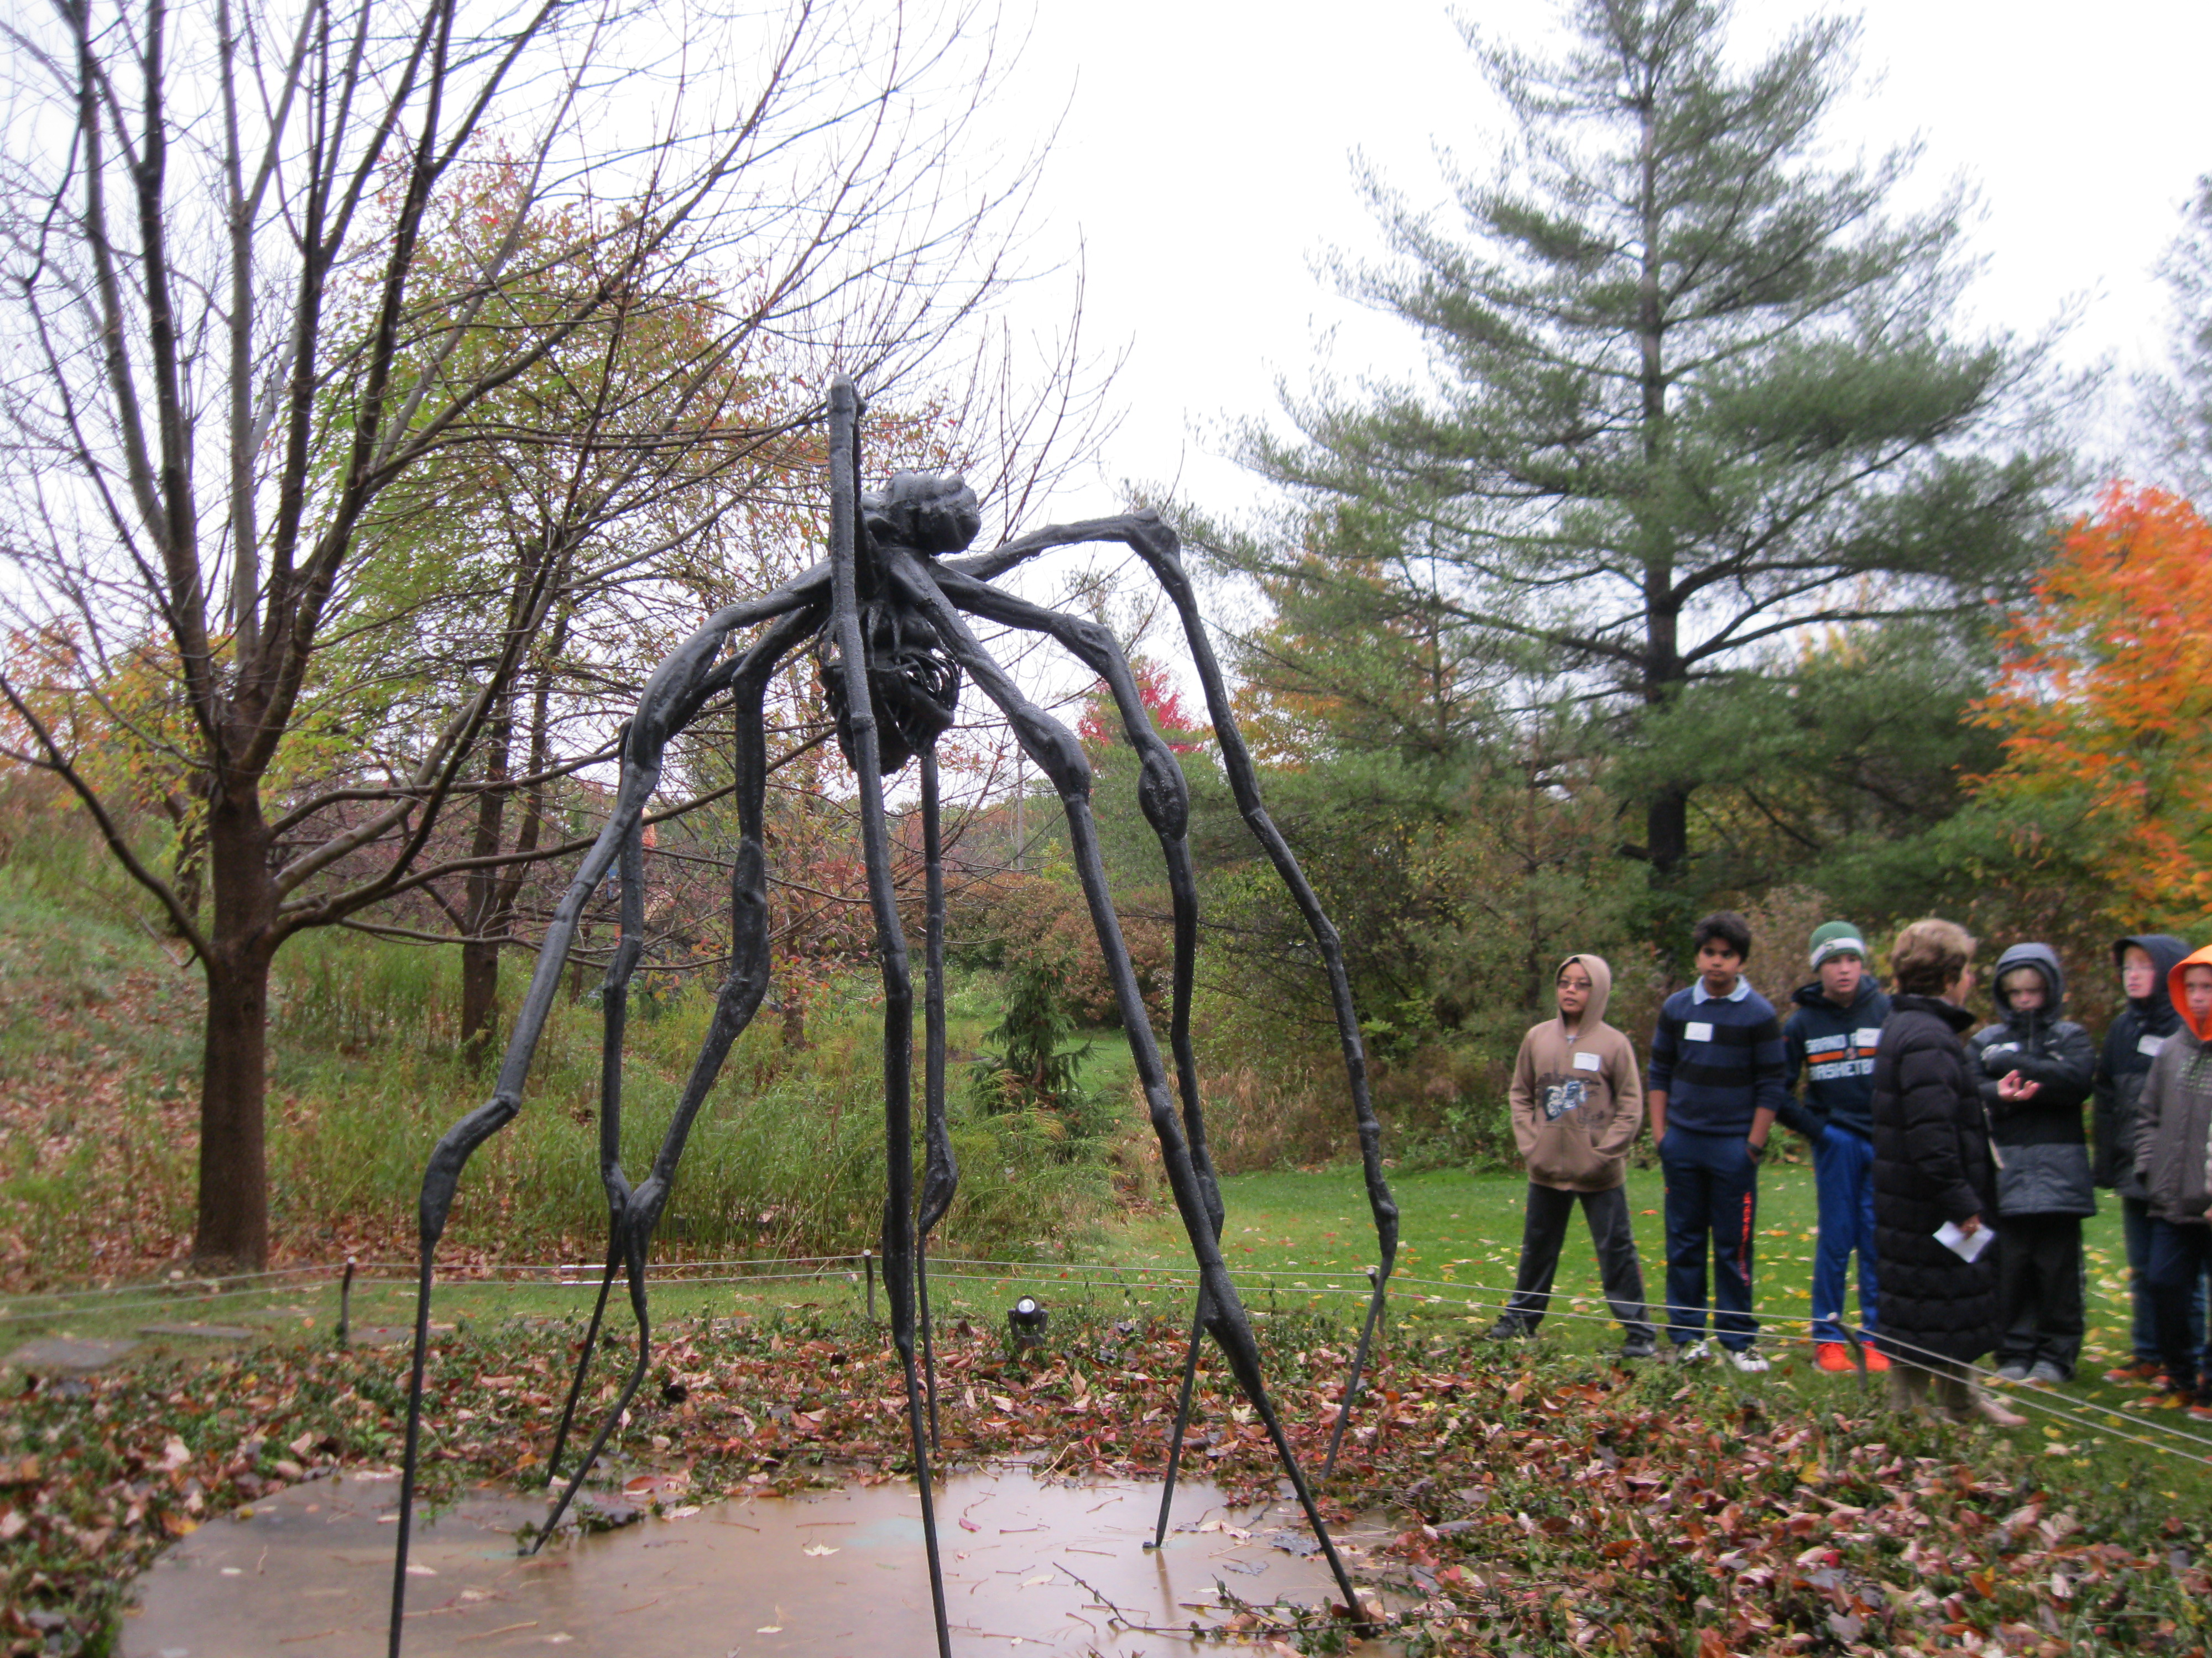
To finish this unit students will be learning about famous pieces of public art from around the world, such as the Statue of Liberty in New York and Cloud Gate in Chicago. This will culminate in each student creating a proposal for a piece of public art that they will design for a specific location in Grandville. This will incorporate many different academic areas as students create three-dimensional sketches using computer software, write their artist’s statement, and make a map of their chosen location. I’m so excited to see what they come up with!
If you’d like to see additional pictures from our field trip, please just visit our classroom website and click on “Student Work” in the menu to the left. Here is the direct link:
6th Grade Student Work

